ASSIGNMENT NO:-1
Aim:- Calculate the sum of all elements in the array.
Source Code:-

import numpy as np
import pandas as pd
data = np.array([10, 20, 30, 40, 50])
df = pd.DataFrame(data, columns=['Numbers'])
total_sum = df['Numbers'].sum()
print("Sum of all elements =", total_sum)

output:-

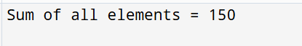

ASSIGNMENT NO:-2

Aim:- Calculate the mean (average) of all elements in the array.
Source code:-
import numpy as np
import pandas as pd
data = np.array([10, 20, 30, 40, 50])
df = pd.DataFrame(data, columns=['Numbers'])
mean_value = df['Numbers'].mean()
print("Mean (average) of all elements =", mean_value)

output:-
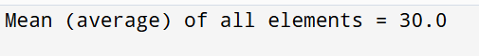

ASSIGNMENT NO:-3

Aim:- . Find the maximum value among all elements in the array.
Source code:-

import numpy as np
import pandas as pd
data = np.array([10, 20, 30, 40, 50])
df = pd.DataFrame(data, columns=['Numbers'])
max_value = df['Numbers'].max()
print("Maximum value among all elements =", max_value)

output:-

ASSIGNMENT NO:-4

Aim:- . Compute the sum of elements along each column (i.e., axis = 0).
Source code:-
import numpy as np
import pandas as pd
data = np.array([[10, 20, 30],
[40, 50, 60],
[70, 80, 90]])

df = pd.DataFrame(data, columns=['A', 'B', 'C'])
column_sum = df.sum(axis=0)
print("Sum of elements along each column:\n", column_sum)

output:-
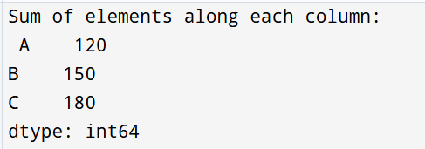

ASSIGNMENT NO:-5

Aim:- Compute the sum of elements along each row (i.e., axis = 1).
Source code:-

import numpy as np
import pandas as pd

data = np.array([[10, 20, 30],
[40, 50, 60],
[70, 80, 90]])

df = pd.DataFrame(data, columns=['A', 'B', 'C'])
row_sum = df.sum(axis=1)
print("Sum of elements along each row:\n", row_sum)

output:-

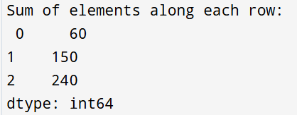

ASSIGNMENT NO:-6

Aim:- Find the maximum value along each column and each row (axis = 0 and axis = 1).
Source code:-
import numpy as np
import pandas as pd
data = np.array([[10, 20, 30],
[40, 50, 60],
[70, 80, 90]])
df = pd.DataFrame(data, columns=['A', 'B', 'C'])
max_column = df.max(axis=0)
max_row = df.max(axis=1)
print("Maximum value along each column:\n", max_column)
print("Maximum value along each row:\n", max_row)

output:-
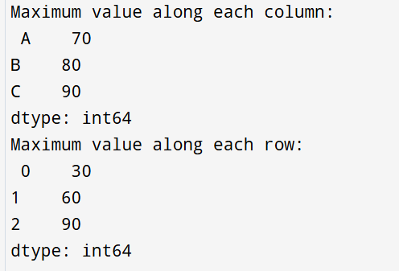

ASSIGNMENT NO:-7
Aim:- Find the minimum value along each column and each row (axis = 0 and axis =1).

Source code:-
import pandas as pd
import numpy as np
data = np.array([[10, 20, 30],
[40, 50, 60],
[70, 80, 90]])
df = pd.DataFrame(data, columns=['A', 'B', 'C'])
min_column = df.min(axis=0)
min_row = df.min(axis=1)
print("Minimum value along each column:\n", min_column)
print("Minimum value along each row:\n", min_row)

output:-
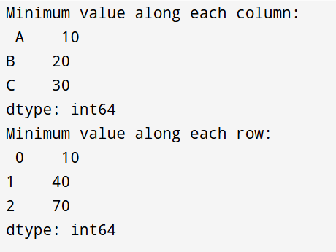
ASSIGNMENT NO:-8
Aim:- Display the DataFrame sorted in descending order of Salary.
Source code:-
import pandas as pd
import numpy as np
df_emp = pd.DataFrame({
'Name': ['Amit', 'Sneha', 'Rahul', 'Priya', 'Karan'],
'Department': ['IT', 'HR', 'IT', 'Finance', 'HR'],
'Salary': np.array([25000, 22000, 28000, 20000, 24000]),
'Status': ['Permanent', 'Contract', 'Permanent', 'Contract', 'Permanent']
})
sorted_salary = df_emp.sort_values(by='Salary', ascending=False)
print(sorted_salary)

output:-
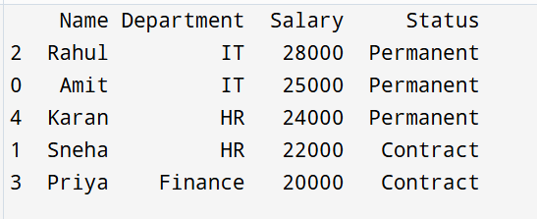

ASSIGNMENT NO:-9
Aim:- Update the Salary of all employees with ‘Contract’ status to ₹19,000.
Source code:-
import pandas as pd
import numpy as np

df_emp = pd.DataFrame({
'Name': ['Amit', 'Sneha', 'Rahul', 'Priya', 'Karan'],
'Department': ['IT', 'HR', 'IT', 'Finance', 'HR'],
'Salary': np.array([25000, 22000, 28000, 20000, 24000]),
'Status': ['Permanent', 'Contract', 'Permanent', 'Contract', 'Permanent']
})
df_emp.loc[df_emp['Status'] == 'Contract', 'Salary'] = 19000
print(df_emp)

output:-
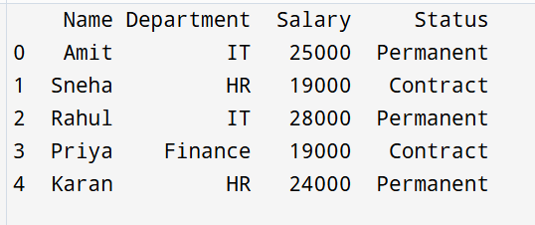
ASSIGNMENT NO:-10
Aim:- Count the total number of employees in each Department.
Source code:-
import pandas as pd
import numpy as np

df_emp = pd.DataFrame({
'Name': ['Amit', 'Sneha', 'Rahul', 'Priya', 'Karan'],
'Department': np.array(['IT', 'HR', 'IT', 'Finance', 'HR'])
})

dept_count = df_emp['Department'].value_counts()
print(dept_count)

output:-
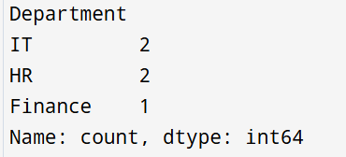

ASSIGNMENT NO:-11
Aim:- Display the maximum salary among employees with ‘Contract’ status.
Source code:-
import pandas as pd
import numpy as np

df_emp = pd.DataFrame({
'Name': ['Amit', 'Sneha', 'Rahul', 'Priya', 'Karan'],
'Salary': np.array([25000, 19000, 28000, 19000, 24000]),
'Status': ['Permanent', 'Contract', 'Permanent', 'Contract', 'Permanent']
})

max_contract_salary = df_emp[df_emp['Status'] == 'Contract']['Salary'].max()
print("Maximum salary among 'Contract' employees =", max_contract_salary)
output:-

ASSIGNMENT NO:-12
Aim:-Display the 4th record of the DataFrame.
Source code:-
import pandas as pd
import numpy as np

df_emp = pd.DataFrame({
'Name': ['Amit', 'Sneha', 'Rahul', 'Priya', 'Karan'],
'Department': np.array(['IT', 'HR', 'IT', 'Finance', 'HR']),
'Salary': np.array([25000, 19000, 28000, 19000, 24000]),
'Status': ['Permanent', 'Contract', 'Permanent', 'Contract', 'Permanent']
})

fourth_record = df_emp.iloc[3]
print("4th record of the DataFrame:\n", fourth_record)

output:-

